LABSHEET02
Harshi Jain , CU240250174, Roll No. - 21

Task 2.1: Interactive Dark-Mode Landing Page
Aim: Create a clean dark-mode landing page using CSS variables and a JavaScript theme toggler.
<!-- index.html -->
<!DOCTYPE html>
<html lang="en">
<head>
<meta charset="UTF-8">
<meta name="viewport" content="width=device-width, initial-scale=1.0">
<title>Dark Mode Landing Page</title>
<link rel="stylesheet" href="style.css">
</head>
<body>
<header class="navbar">
<h2>DarkSpace</h2>
<button id="themeBtn"> Light Mode</button>
</header>
<main class="hero">
<p class="tag">MODERN • SIMPLE • RESPONSIVE</p>
<h1>Build Better Experiences.</h1>
<p>Explore a clean landing page with an interactive theme switcher.</p>
<button class="cta">Get Started</button>
</main>
<script src="script.js"></script>
</body>
</html>
/* style.css */
:root {
--bg: #0b1020;
--surface: #151c32;
--text: #f5f7ff;
--muted: #aab3c8;
--accent: #6c63ff;
}
body.light {
--bg: #f4f6fb;
--surface: #ffffff;
--text: #111827;
--muted: #5b6475;
--accent: #4f46e5;
}
* { box-sizing: border-box; margin: 0; padding: 0; }
body { min-height: 100vh; font-family: Arial, sans-serif; background: var(--bg); color: var(--text); transition: background .3s, color .3s;
}
.navbar { display: flex; justify-content: space-between; align-items: center; padding: 20px 7%; background: var(--surface);
}
button {
border: 0; border-radius: 10px; padding: 10px 16px; background: var(-accent); color: white; cursor: pointer;
}
.hero { min-height: calc(100vh - 80px); display: grid; placeitems: center; text-align: center; padding: 40px 7%;
}
.hero h1 { font-size: clamp(42px, 7vw, 76px); margin: 15px 0; }
.hero p:not(.tag) { color: var(--muted); line-height: 1.7; margin-bottom: 25px; }
.tag { color: var(--accent); font-weight: bold; }
@media (max-width: 600px) {
.navbar { padding: 16px 5%; }
}
/* script.js */ const themeBtn = document.getElementById("themeBtn");
themeBtn.addEventListener("click", () => {
document.body.classList.toggle("light"); const isLight = document.body.classList.contains("light"); themeBtn.textContent
= isLight ? " Dark Mode" : "Light Mode"; });
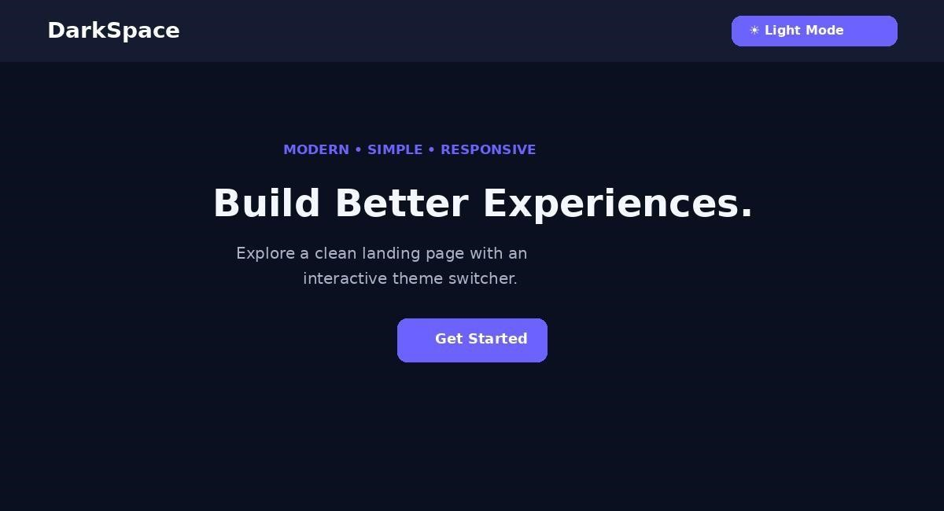

Task 2.2: Responsive Photo Grid Using Flexbox
Aim: Create a responsive photo grid that wraps on smaller screens and applies a hover transform.
<!-- index.html -->
<!DOCTYPE html>
<html lang="en">
<head>
<meta charset="UTF-8">
<meta name="viewport" content="width=device-width, initial-scale=1.0">
<title>Photo Grid</title>
<link rel="stylesheet" href="style.css">
</head>
<body>
<h1>My Photo Gallery</h1>
<div class="gallery">
<div class="photo"><img src="https://picsum.photos/id/1015/600/400" alt="Mountain"></div>
<div class="photo"><img src="https://picsum.photos/id/1011/600/400" alt="Landscape"></div>
<div class="photo"><img src="https://picsum.photos/id/1025/600/400" alt="Dog"></div>
<div class="photo"><img src="https://picsum.photos/id/1035/600/400" alt="River"></div>
<div class="photo"><img src="https://picsum.photos/id/1043/600/400" alt="Forest"></div>
<div class="photo"><img src="https://picsum.photos/id/1069/600/400" alt="Nature"></div>
</div>
</body>
</html>
/* style.css */
* { box-sizing: border-box; }
body {
margin: 0; padding: 35px 6%; font-family: Arial, sansserif; background: #f4f6f8;
} h1 { text-align: center; margin-bottom: 30px;
}
.gallery { display: flex; flex-wrap: wrap; gap: 20px;
justify-content: center;
}
.photo { flex: 1 1
280px; max-width: 380px; overflow: hidden; borderradius: 14px;
}
.photo img { display: block; width: 100%; height: 240px; object-fit: cover;
transition: transform .35s ease;
}
.photo:hover img { transform: scale(1.08);
}
@media (max-width: 600px) {
.photo { flex-basis: 100%; max-width: none; }
.photo img { height: 220px; }
}


Task 2.3: Client-Side Interactive Todo Application
Aim: Build a Todo app using runtime DOM element creation and validation error messages.
<!DOCTYPE html>
<html lang="en">
<head>
<meta charset="UTF-8">
<meta name="viewport" content="width=device-width, initial-scale=1.0">
<title>Todo Application</title>
<style> body { font-family: Arial; background:#eef2f7; padding:50px
20px; }
.todo-box { max-width:600px; margin:auto; background:white; padding:28px; border-radius:16px; }
.input-row { display:flex; gap:10px; }
#taskInput { flex:1; padding:12px; border:1px solid #ccd3df; border-radius:8px; } button { padding:12px 16px; border:0; border-radius:8px; background:#4f46e5; color:white; cursor:pointer; } #error { color:#dc2626; min-height:22px; margintop:8px; } li { display:flex; justify-content:space-between; padding:12px;
margin-top:10px; background:#f5f7fb; border-radius:8px; }
.delete { background:#dc2626; padding:7px 10px; } </style>
</head>
<body>
<div class="todo-box">
<h1>Todo Application</h1>
<div class="input-row">
<input id="taskInput" type="text" placeholder="Enter a task">
<button id="addBtn">Add</button>
</div>
<div id="error"></div>
<ul id="todoList"></ul>
</div>
<script> const input = document.getElementById("taskInput"); const addBtn = document.getElementById("addBtn"); const list = document.getElementById("todoList"); const error = document.getElementById("error");
function addTask() { const task =
input.value.trim();
if (task === "") { error.textContent =
"Please enter a task."; input.focus();
return; } error.textContent = "";
const li = document.createElement("li"); const span
= document.createElement("span"); const deleteBtn
= document.createElement("button");
span.textContent = task; deleteBtn.textContent = "Delete"; deleteBtn.className = "delete"; deleteBtn.addEventListener("click", () => li.remove());
li.appendChild(span); li.appendChild(deleteBtn); list.appendChild(li);
input.value = ""; input.focus(); }
addBtn.addEventListener("click", addTask);
input.addEventListener("keydown", (event) => {
if (event.key === "Enter") addTask();
});
</script>
</body>
</html>
